CURRICULUM VITAE
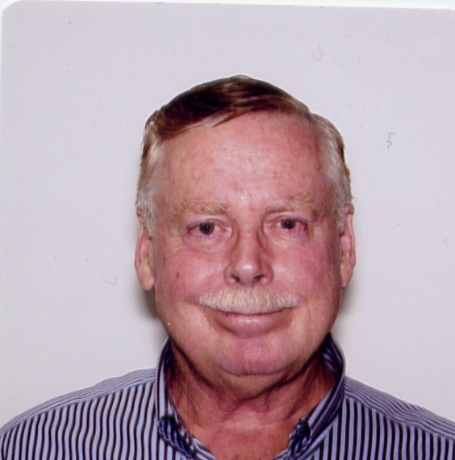

Name: B. Grant Logan

Email and cell: bglogan@lbl.gov, also logan1@llnl.gov.
Mobile phone (510) 847-3124

Home Address: 833 Ackerman Drive
Danville, California 94526
(925) 820-1735

Date of Birth: October 1, 1946

Place of Birth: Las Cruces, New Mexico

Citizenship: USA

Marital Status: Married to Nancy Ann Logan
Two children: Jennifer Ann (birth date 1978)
Brian Raymond (birth date 1980)

Education: University of California
Berkeley, California
Ph.D. in Engineering Science (1972)
MS Nuclear Engineering (1969)

New Mexico State University
College Park, New Mexico
BS Physics (1968)

Honors: Graduated first in class from New Mexico State University
U.S. Atomic Energy Commission Fellowship National Research Council Post-doctoral Fellowship (1973-1974)
American Physical Society Fellow (1979)
E. O. Lawrence Memorial Award (1980)
Named one of the Top 100 Young Scientists by Science Digest Magazine (December 1984)
Fusion Power Associates Leadership Award (1999)
Fusion Power Associates Distinguished Career Award (2012)

Research: Experimental plasma physics; physics and engineering design of fusion experiments, technical management of advanced technology development groups, and strategic program planning.

Membership: American Physical Society, member 1970 to present
American Nuclear Society, member 1984 to present

Employment History:
March 6, 2015 to present:
Visiting Scientist working with CEA-DIF, LPGP- U. Orsay Paris Sud, and LULI-Ecole Polytechnique under a LabEX-PALM grant # ANR-10-LABX-0039

December 5, 2013 through February 27, 2015
Self-Employed Scientific Consultant to Lawrence Livermore National Laboratory, Livermore, California, USA and to Sandia National Laboratory, Albuquerque, New Mexico, USA, both related to magnetized ICF targets.

October 7 through November 17, 2013
Visiting Professor at Institute of Laser Engineering Osaka University, Japan
working on magnetized fast ignition target physics.

June 29, 2012 to present
Retired from University of California and Lawrence Berkeley National Laboratory. Retired (unpaid) Affiliate of LBNL and LLNL.

March 2001 to June 29, 2012
Director, U.S. Heavy Ion Fusion Science Virtual National Laboratory
Lawrence Berkeley National Laboratory (LBNL)

October 1992 to March 2001
Associate Program Leader for ICF Applications Group
Lawrence Livermore National Laboratory
And Deputy Director for Heavy Ion Fusion Virtual National Laboratory (LLNL-LBNL)

February 1987 to October 1992
Deputy Associate Director, Magnetic Fusion Energy Program
Lawrence Livermore National Laboratory

January 1983 to February 1987
Program Leader, Fusion Reactor Technology and Conceptual Design Group
Lawrence Livermore National Laboratory

August 1974 to January 1983
Physicist, Magnetic Fusion Energy Program
Lawrence Livermore National Laboratory

January 1974 to August 1974
Physicist, U. S. Naval Research Laboratory
Washington, DC

January 1973 to January 1974
Post-Doctoral Research Associate
U.S. Naval Research Laboratory
Washington, DC

Selected Recent Publications:
L. J. Perkins, B. G. Logan, G. B. Zimmerman, and C. J. Werner, "The application of compressed magnetic fields to the ignition and thermonuclear burn of inertial confinement fusion targets" Physics of Plasmas 20, 072708 (July 2013)

E. Henestroza and B. G Logan "Progress towards a high-gain and robust target design for HIF" Physics of Plasmas 19, 072706 (2012)

E. Henestroza, B. G. Logan, and L. J. Perkins, "The X-target: Quasi-spherical fuel compression and fast ignition in a heavy-ion driven X-target with one sided illumination" Physics of Plasmas 18, 032702 (2011).

B. G. Logan, L. J. Perkins, and J. J. Barnard, "Direct Drive Heavy-Ion-Beam Inertial Fusion at High Coupling Efficiency" Physics of Plasmas 15, 072701 (2008).

B. Grant Logan, Roger O. Bangerter, Debra A. Callahan, Max Tabak, Markus Roth, L. John Perkins, George Caporaso “Assessment of potential for ion-driven fast ignition” Fusion Science and Technology Volume 49 · Number 3 · (2006)

